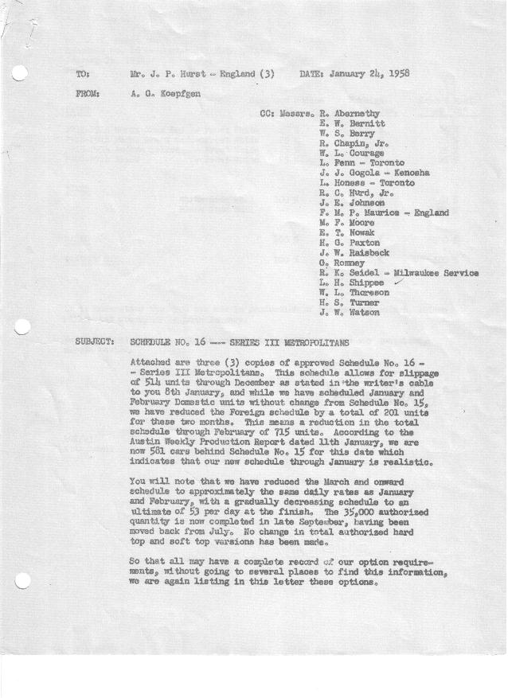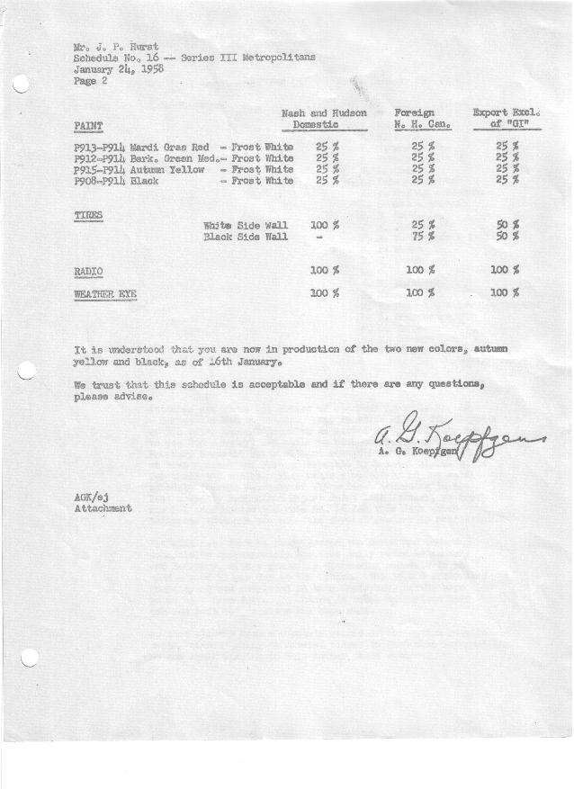

FORM AM 1262 Page 1 of 2 APPROVED R. Abernethy (signed) DATE 1-28-58

SCHEDULE NO. ______16 ___ DATE 1-22-58 MONTHLY BUILDING SCHEDULE APPROVED R. W.Chapin Jr. (signed) DATE_ 1-29-58 _
REVISION NO. _______ ______ DATE PRODUCT APPROVED E.W.Bernitt (signed) ___ _DATE _ 1-30-58 ____
SERIES III 1500 c.c. ENGINE
METROPOLITAN SERIES CARS – AUSTIN MOTORS CO., LTD, ENGLAND
DESCRIPTION | BUILT  ◻ACT EST  THRU  Dec. | FIRM BUILDING SCHEDULE  (FABRICATED MATERIAL RELEASE) |  |  |  |  |  |  |  |  |  |  |  |  |  |  | TENTATIVE SCHEDULE  (RAW MATERIAL RELEASED) |  |  | GRAND  TOTAL
DESCRIPTION | BUILT  ◻ACT EST  THRU  Dec. | MONTH January “58”  DAYS 23 |  |  | MONTH February  DAYS 20 |  |  | MONTH March  DAYS 21 |  |  | MONTH April  DAYS 20 |  |  | MONTH May  DAYS 22 |  |  | MONTH June  DAYS 19 |  |  | GRAND  TOTAL
DESCRIPTION | BUILT  ◻ACT EST  THRU  Dec. | DAILY | MONTH | CUM’L  TOTAL | DAILY | MONTH | CUM’L  TOTAL | DAILY | MONTH | CUM’L  TOTAL | DAILY | MONTH | CUM’L  TOTAL | DAILY | MONTH | CUM’L  TOTAL | DAILY | MONTH | CUM’L TOTAL | GRAND  TOTAL
DOMESTIC LHD:
Hard-Top | 18353 |  | 1159 | 19512 |  | 914 | 20426 |  | 806 | 21232 |  | 816 | 22048 |  | 898 | 22946 |  | 775 | 23721
Soft-Top | 2879 |  | 157 | 3036 |  | 229 | 3265 |  | 202 | 3467 |  | 144 | 3611 |  | 158 | 3769 |  | 137 | 3906
Total U.S. | 21232 | 57.2 | 1316 | 22548 | 57.2 | 1143 | 23691 | 48.0 | 1008 | 24699 | 48.0 | 960 | 25659 | 48.0 | 1056 | 26715 | 48.0 | 912 | 27627
Over/(Under) Schedule 15 | (334) |  | -0- | (334) |  | -0- | (334) |  | (378) | (712) |  | (360) | (1072) |  | (264) | (1336) |  | (228) | (1564)
FOREIGN:
EXPORT LHD Hard-Top | 645 |  | 30 | 675 |  | 30 | 705 |  | 30 | 735 |  | 30 | 765 |  | 22 | 787 |  | 22 | 809
Soft-Top | 307 |  | 10 | 317 |  | 9 | 326 |  | 10 | 336 |  | 10 | 346 |  | 8 | 354 |  | 8 | 362
Total Export LHD | 952 |  | 40 | 992 |  | 39 | 1031 |  | 40 | 1071 |  | 40 | 1111 |  | 30 | 1141 |  | 30 | 1171
RHD Hard Top | 251 |  | 35 | 286 |  | 30 | 316 |  | 30 | 346 |  | 35 | 381 |  | 35 | 416 |  | 35 | 451
Soft Top | 40 |  | 2 | 42 |  | 4 | 46 |  | 9 | 55 |  | 5 | 60 |  | 5 | 65 |  | 5 | 70
Total Export RHD | 291 |  | 37 | 328 |  | 34 | 362 |  | 39 | 401 |  | 40 | 441 |  | 40 | 481 |  | 40 | 521
Total Export LHD & RHD | 1243 | 3.4 | 77 | 1320 | 3.6 | 73 | 1393 | 3.8 | 79 | 1472 | 4.0 | 80 | 1552 | 3.2 | 70 | 1622 | 3.7 | 70 | 1692
Over/(Under) Schedule 15 | (130) |  | (41) | (171) |  | -0- | (18) |  | (1) | (172) |  | 18 | (154) |  | 4 | (150) |  | -0- | (150)
CANADA Hard-Top | 1923 |  | 54 | 1977 |  | 20 | 1997 |  | 168 | 2165 |  | 141 | 2306 |  | 130 | 2436 |  | 56 | 2492
Soft-Top | 148 |  | 6 | 154 |  | 5 | 159 |  | 30 | 189 |  | 30 | 219 |  | 30 | 249 |  | 9 | 258
Total Canada | 2071 | 2.6 | 60 | 2131 | 1.3 | 25 | 2156 | 9.4 | 198 | 2354 | 8.6 | 171 | 2525 | 7.2 | 160 | 2685 | 3.4 | 65 | 2750
Over/(Under) Schedule 15 | (50) |  | (55) | (105) |  | (105) | (210) |  | (52) | (262) |  | (64) | (326) |  | (55) | (381) |  | 5 | (376)
Total Foreign | 3314 | 6.0 | 137 | 3451 | 4.9 | 98 | 3549 | 13.2 | 277 | 3826 | 12.6 | 251 | 4077 | 10.4 | 230 | 4307 | 7.1 | 135 | 4442
Over/(Under) Schedule 15 | (180) |  | (96) | (276) |  | (105) | (381) |  | (53) | (434) |  | (46) | (480) |  | (51) | (531) |  | 5 | (526)
GRAND TOTALS
Hard-Top | 21172 | 55.5 | 1278 | 22450 | 49.6 | 994 | 23444 | 49.3 | 1034 | 24478 | 51.1 | 1022 | 25500 | 49.3 | 1085 | 26585 | 46.7 | 888 | 27473
Soft-Top | 3374 | 7.7 | 175 | 3549 | 12.5 | 247 | 3796 | 11.9 | 251 | 4047 | 9.5 | 189 | 4236 | 9.1 | 201 | 4437 | 8.4 | 159 | 4596
Total | 24546 | 63.2 | 1453 | 25999 | 62.1 | 1241 | 27240 | 61.2 | 1285 | 28525 | 60.6 | 1211 | 29736 | 58.4 | 1286 | 31022 | 55.1 | 1047 | 32069
Over/(Under) Schedule 15 | (514) |  | (96) | (610) |  | (105) | (715) |  | (431) | (1146) |  | (406) | (1552) |  | (315) | (1867) |  | (223) | (2090)

FORM AM 1262 Page 2 of 2 APPROVED R. Abernethy (signed) DATE 1-28-58

SCHEDULE NO. ______16 ___ DATE 1-22-58 MONTHLY BUILDING SCHEDULE APPROVED R. W.Chapin Jr. (signed) DATE_ 1-29-58 _
REVISION NO. _______ ______ DATE PRODUCT APPROVED E.W.Bernitt (signed) ___ _DATE _ 1-30-58 ____
SERIES III 1500 c.c. ENGINE
METROPOLITAN SERIES CARS – AUSTIN MOTORS CO., LTD, ENGLAND
DESCRIPTION | BUILT  ◻ACT◻ EST  THRU | FIRM BUILDING SCHEDULE  (FABRICATED MATERIAL RELEASE) |  |  |  |  |  |  |  |  |  |  |  |  |  |  | TENTATIVE SCHEDULE  (RAW MATERIAL RELEASED) |  |  | GRAND  TOTAL
DESCRIPTION | BUILT  ◻ACT◻ EST  THRU | MONTH July  DAYS 14 |  |  | MONTH August  DAYS 20 |  |  | MONTH September  DAYS 19.5 (22 Available) |  |  | MONTH  DAYS |  |  | MONTH  DAYS |  |  |  |  |  | GRAND  TOTAL
DESCRIPTION | BUILT  ◻ACT◻ EST  THRU | DAILY | MONTH | CUM’L  TOTAL | DAILY | MONTH | CUM’L  TOTAL | DAILY | MONTH | CUM’L  TOTAL | DAILY | MONTH | CUM’L  TOTAL | DAILY | MONTH | CUM’L  TOTAL | DAILY | MONTH | CUM’L TOTAL | GRAND  TOTAL
DOMESTIC LHD:
Hard-Top |  |  | 591 | 24312 |  | 845 | 25157 |  | 826 | 25983
Soft-Top |  |  | 81 | 3987 |  | 115 | 4102 |  | 98 | 4200
Total U.S. |  | 48.0 | 672 | 28299 | 48.0 | 960 | 29259 | 48.0 | 924 | 30183
Over/(Under) Schedule 15 |  |  | (57) | (1621) |  | 960 | (661) |  | 924 | 263
FOREIGN:
EXPORT LHD Hard-Top |  |  | 30 | 839 |  | 30 | 869 |  | 30 | 899
Soft-Top |  |  | 10 | 372 |  | 10 | 382 |  | 10 | 392
Total Export LHD |  |  | 40 | 1211 |  | 40 | 1251 |  | 40 | 1291
RHD Hard Top |  |  | 35 | 486 |  | 35 | 521 |  | 35 | 556
Soft Top |  |  | 5 | 75 |  | 5 | 80 |  | 5 | 85
Total Export RHD |  |  | 40 | 561 |  | 40 | 601 |  | 40 | 641
Total Export LHD & RHD |  | 5.7 | 80 | 1772 | 4.0 | 80 | 1852 | 3.6 | 80 | 1932
Over/(Under) Schedule 15 |  |  | 20 | (130) |  | 80 | (50) |  | 80 | 30
CANADA Hard-Top |  |  | 51 | 2543 |  | 50 | 2593 |  | 25 | 2618
Soft-Top |  |  | 9 | 267 |  | 0 | 267 |  | 0 | 267
Total Canada |  | 4.3 | 60 | 2810 | 2.5 | 50 | 2860 | 1.2 | 25 | 2885
Over/(Under) Schedule 15 |  |  | 8 | (368) |  | 50 | (318) |  | 25 | (293)
Total Foreign |  | 10.0 | 140 | 4582 | 6.5 | 130 | 4712 | 4.8 | 105 | 4817
Over/(Under) Schedule 15 |  |  | 28 | (498) |  | 130 | (368) |  | 105 | (263)
GRAND TOTALS
Hard-Top |  | 50.5 | 707 | 28180 | 48.0 | 960 | 29140 | 47.3 | 916 | 30056
Soft-Top |  | 7.5 | 105 | 4701 | 6.5 | 130 | 4831 | 5.5 | 113 | 4944
Total |  | 58.0 | 812 | 32881 | 54.5 | 1090 | 33971 | 52.8 | 1029 | 35000
Over/(Under) Schedule 15 |  |  | (29) | (2119) |  | 1090 | (1029) |  | 1029 | -0-

